A kd-tree is like a binary tree, except it can be drawn on any no of dimesnions, the kd-tree looks like this.

To draw this following steps need to be perfomed:

* Pick x axis, project points onto x axis, compute median, then split data points using median. And the draw tree according to observed points.
* Alternate the axis and then do the same process, till we reach leaf.

If there are 2 axis then process will go as (x – y – x – y …..)

If there are 3 axis then process will go as (x – y – z - x – y – z - ……).

And same for n-dimensions.

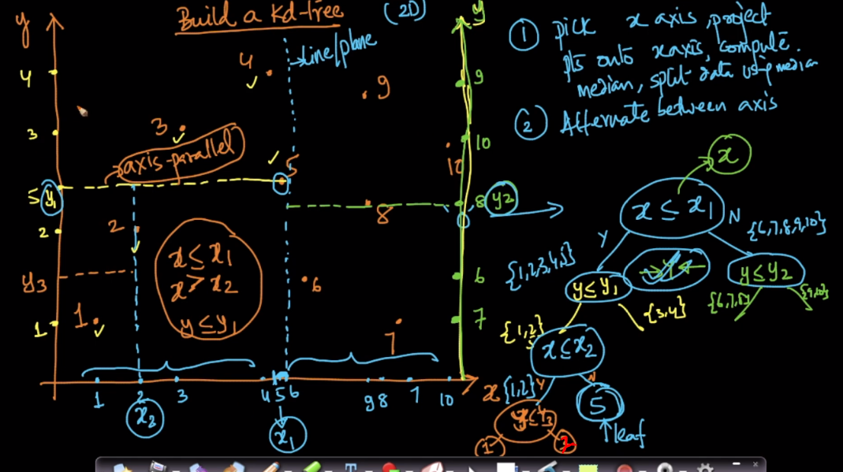

Let’s look at this step by step.

First we project all the points on x-axis, then find the median of this, the median is avg of 5 and 6.

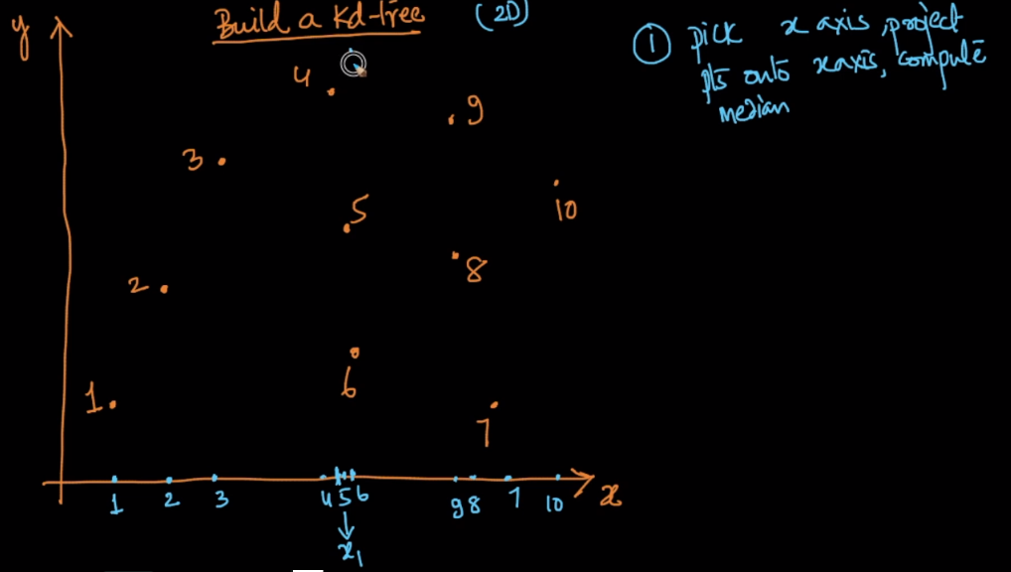

Split it on the median, so on left side or equal to that of median we have 1,2,3,4,5 and on right side 6,7,8,9,10. And similarly draw tree for this.

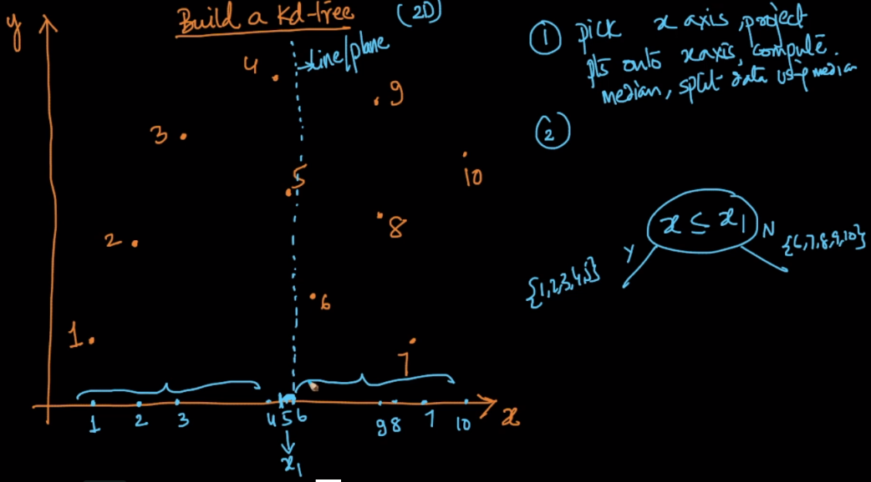

Now we’ll do same for y-axis, first we’ll do to left splitted portion as.

We find the median, median is 5, so we draw a line on that point.

Points on left or equal to median are 1, 2, 5 and point greater than median are 3, 4

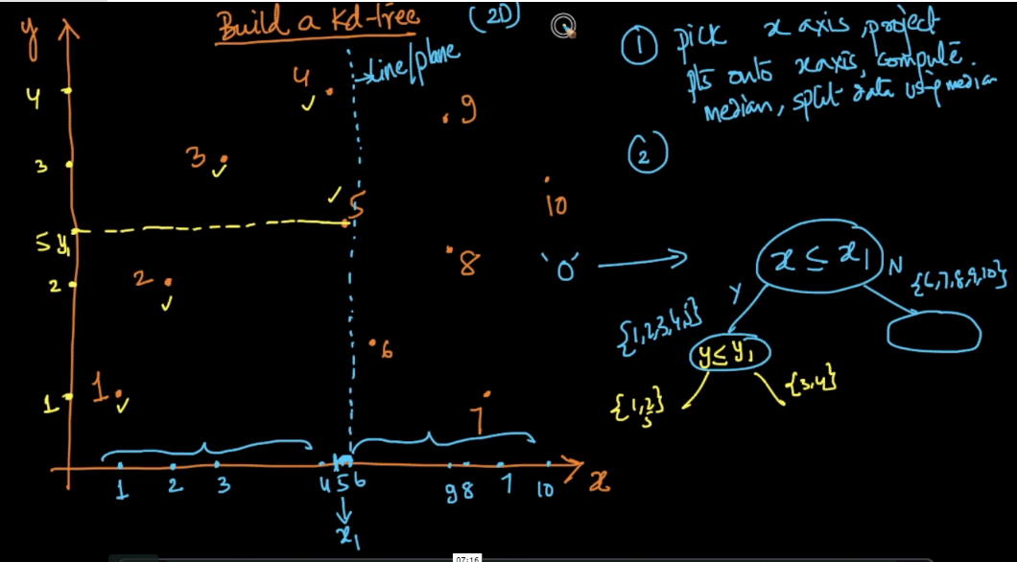

Similarly we do for right side of x splitted, and draw tree.

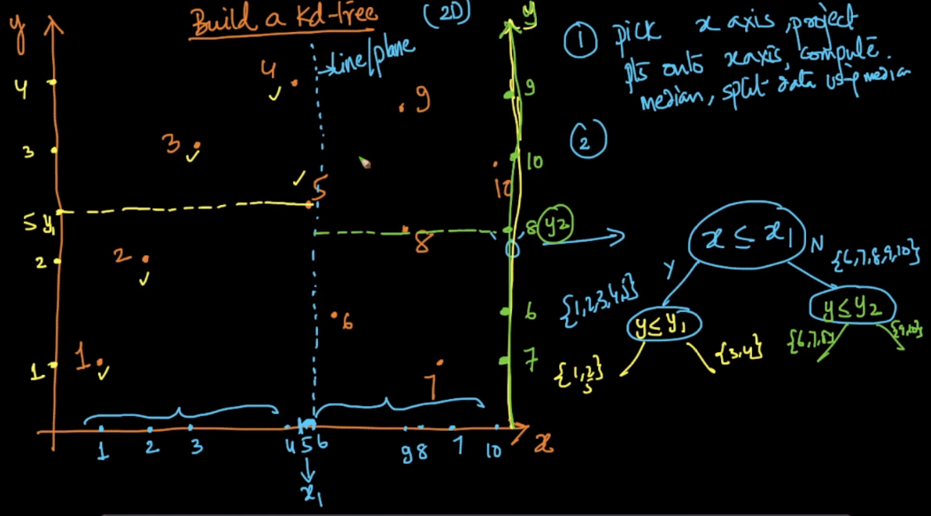

Now splitting is done on y-axis so again we do splitting on x-axis for all the boxes.

Let’s understand for bottom left box

We pick median which is 2, draw a line on it.

Points left or equal to of median are 1, 2 and to right are 3. Now draw tree accordingly.

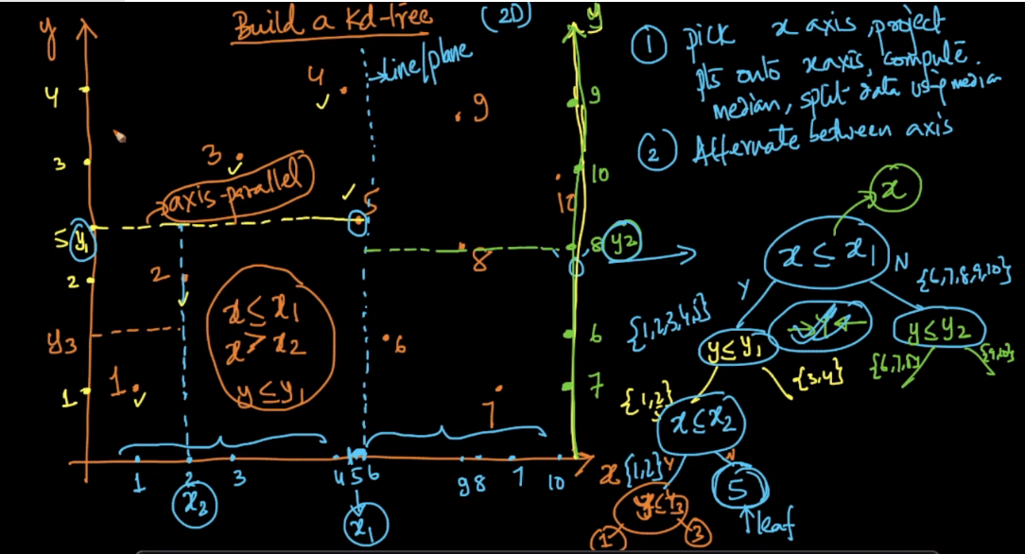

And this process continues until we reach leaf where all the elements are presents.

Therefore 2D axis we will get recatangles.

For 3D we’ll get cuboids.

For nD we’ll get hypercuboids.

